**ROSHNI RAZA**

**SAP ID :**

**LAB : 06**

**TASK 01:**

.model small

.stack 100h

.data

firstName DB ' Name :Roshni $'

age DB 'Age :21$'

occupation DB 'Occupation:Software Developer$'

email DB 'Gmail id:roshniR@gmail.com$'

phone DB 'Phone number:123-456-7890$'

.code

main proc

mov ax, @data

mov ds, ax

mov dx, offset firstName

mov ah, 9

int 21h

mov dl, 13

mov ah, 2

int 21h

mov dl, 10

mov ah, 2

int 21h

mov dx, offset age

mov ah, 9

int 21h

mov dl, 13

mov ah, 2

int 21h

mov dl, 10

mov ah, 2

int 21h

mov dx, offset occupation

mov ah, 9

int 21h

mov dl, 13

mov ah, 2

int 21h

mov dl, 10

mov ah, 2

int 21h

mov dx, offset email

mov ah, 9

int 21h

mov dl, 13

mov ah, 2

int 21h

mov dl, 10

mov ah, 2

int 21h

mov dx, offset phone

mov ah, 9

int 21h

mov ah, 4Ch

int 21h

main endp

end main

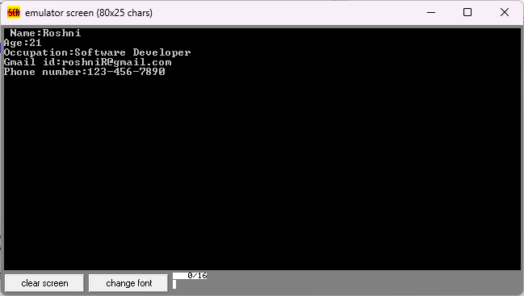

**TASK 02:**

.model small

.stack 100h

.data

prompt DB 'Enter a character: $'

msg DB 'The user entered $ character.$'

newline DB 13, 10, '$'

.code

main proc

mov ax, @data

mov ds, ax

mov dx, offset prompt

mov ah, 09h

int 21h

mov ah, 01h

int 21h

mov bl, al

mov dx, offset newline

mov ah, 09h

int 21h

mov dx, offset msg

mov ah, 09h

int 21h

mov dl, bl

mov ah, 02h

int 21h

mov dx, offset newline

mov ah, 09h

int 21h

mov ah, 4Ch

int 21h

main endp

end main

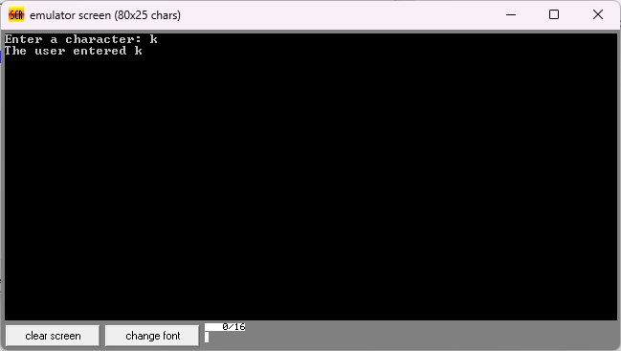

**TASK 03:**

.model small

.stack 100h

.data

prompt DB 'Enter a character: $'

msg DB 'The user entered $ character.$'

newline DB 13, 10, '$'

.code

main proc

mov ax, @data

mov ds, ax

mov dx, offset prompt

mov ah, 09h

int 21h

mov ah, 01h

int 21h

mov bl, al

cmp bl, 'a'

jl not_lower

cmp bl, 'z'

jg not_lower

sub bl, 32

not_lower:

mov dx, offset newline

mov ah, 09h

int 21h

mov dx, offset msg

mov ah, 09h

int 21h

mov dl, bl

mov ah, 02h

int 21h

mov dx, offset newline

mov ah, 09h

int 21h

mov ah, 4Ch

int 21h

main endp

end main

